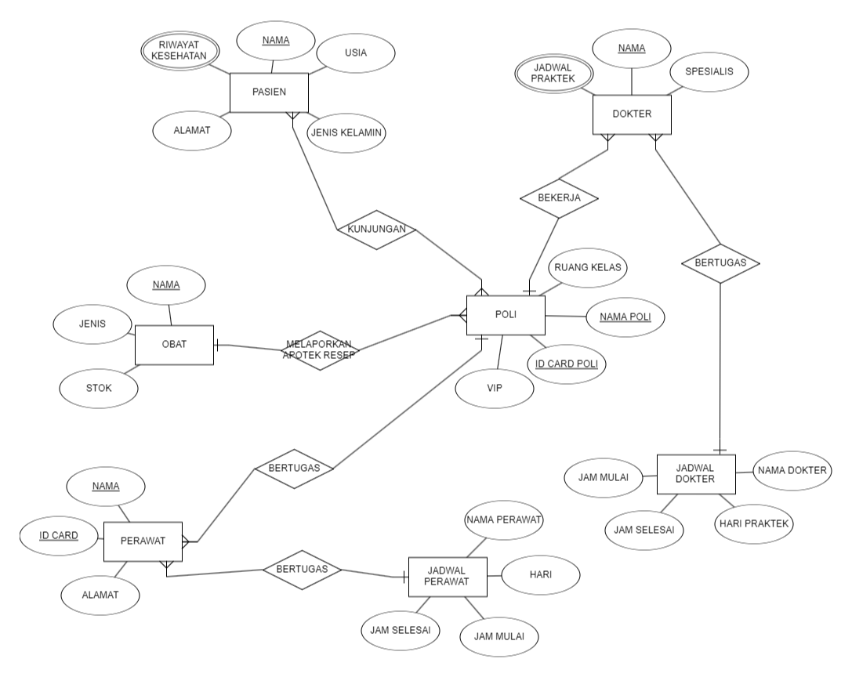**A . ERDPLUS DIAGRAM**

B . TIPE ATRIBUT

1. PASIEN

* Simple atribut
* Nama,,jenis kelamin
* Derived atribut
* Usia
* Multivalued atribut
* Riwayat Kesehatan
* Composite
* Alamat
* Key atribut

-

1. DOKTER

* Simple atribut
* nama, spesialis
* Derived atribut
* Multivalued atribut
* Jadwal praktek
* Composite stribut

-

* Key atribut

-

1. POLI

* Simple atribut
* Nama poli
* Derived atribut

-

* Multivalued atribut
* Composite atribut

-

* Opsional
* Ruang kelas, VIP
* Key atribut
* Id card poli

1. Perawat

* Simple atribut
* Nama
* Derived atribut

-

* Multivalued atribut

-

* Composite atribut
* Alamat
* Key atribut
* Id card

1. Obat

* Simple atribut
* nama
* Derived obat
* Multivalud atribut
* Composite atribut
* Key atribut
* -

1. Jadwal perawat

* Simple atribut

-

* Derived atribut
* Multivalued atribut
* Composite atribut
* Key atribut

1. Jadwal dokter

* Simple atribut
* Derived atribut
* Multivalued atribut
* Composite atribut
* Key atribut